CHC Coalition Meeting Minutes
July 20, 2020
Attendees: T. Riegel, A. Riegel, S. Urban, S. Hammond, S. Donaldson, A. Reichle, S. Maxwell, D. McDaniel, T. Payne-Throckmorton, T. West, C. Carver, B. Chaney, Courier, M. Robson, S. Crapes, S. Ray, J. Bentley, B. Rannells
Agenda:
- Intro to new CHC Coordinator
- Define what CHC is and how it can help VC
- VC health factor comparison w/ state and national averages
- Review/Update 2020 grant
  - Discuss barriers to progress
  - Get input from members on potential FM vendors and /or worksite for FSG Policy
- Brief intro to 2021 Work Plan
  - Need to form subcommittees
- Plan for next meeting in early August to form subcommittees
Updates:
- 2021 Work Plan/Budget due on 7/27/2020
- Moving forward with Farmers’ market expansion and healthy vending
- Adding community garden objective for 2021
- Cataloging all current parks/playgrounds in county
- Assessing sidewalks/safe routes to schools across VC
- Assessing need for bike infrastructure around McArthur to encourage bike riding
- Collaborating with other area businesses/officials to meet objectives
- Continue to work on healthy vending strategies
- New or repaired parks goal for 2021
- VC Farmers Market is doing well. Need more vendors for both locations
Next Meeting:
Week of Aug 3-7 to create subcommittees for objective goal success!! Survey coming soon.

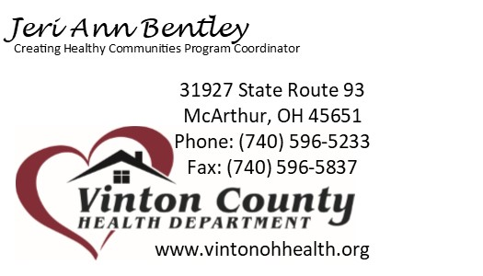
For more information contact:

Email:
jbentley@vintonohhealth.org

