Committee Planning Meeting
8/6/2020
Attendees: Dr. Sue Crapes, Susan Urban, Troy Howdyshell, Lisa Bentley, Bernadette Chaney, Anne Reichle, Ashley Riegel, Travis West, Lori Simonton, Cassie Carver, Jeri Ann Bentley
Agenda:
- CHC Updates
- Steering vs Subcommittee
- Active Living vs Healthy Eating Committees
- Overview of 2020 & 2021 objectives for each category
- Questions, Concerns, Comments
- Committee Building
Committees: SO FAR this is who has committed.
- Active Living: Sarah Ray, Troy Howdyshell, Lisa Bentley
- Healthy Eating: Bob Rannells, Susan Urban, Ashley Riegel, Miranda Smith, Anne Reichle, and Lori Simonton
CHC Updates:
- Submitted 2021 Work Plan on 7/27/2020 to ODH
- Completed first draft of 2020 revision to include Complete Streets Policy for Vinton Co. (2 year objective)
- Researching Complete Street Policies in neighboring counties
- Researching Food Service Guidelines in neighboring counties
- Courier Ads for Coalition meetings & Farmers’ Market
- Telegram & Courier articles re: CHC Coalition
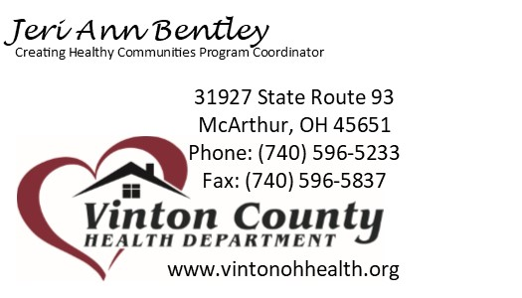
Next Meetings:
- Active Living Committee – August 27 – Time TBD
- Healthy Eating Committee – August 27 – Time TBD
- Coalition – September 10 – Time TBD

