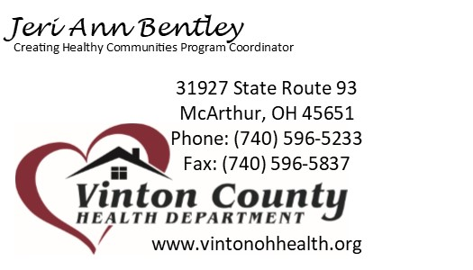
Active Living Subcommittee Meeting
9/10/2020
Attendees: (in person) Tammy Riegel, Sarah Ray, Brandi Betts, Connie Zickafoose, Dr. Sue Crapes, Susan Urban, Cassie Carver, and Travis West (virtually) Troy Thacker, Tina Spanos, Lisa Bentley, Davalene McDaniel

Updates:
- Awaiting budget approval to start purchasing campaign materials to promote complete streets
- Have had meeting with Steve Hammond re: complete streets policies, safe routes to school, and park expansion options
Complete Streets:
- Materials Provided: Brochure, Complete Streets Fact Sheet, Complete Streets FAQ, Complete Streets in Rural Communities article.
- Making sure all of our streets are accessible to everyone regardless of ability or mode of transportation
  - Examples: traffic calming (speed bumps, dec speed limit, cross walks, signage, etc), widened sidewalks, widened berms, curb cuts, etc.
- Encourage EQUITY, not just equality.
- Inc pedestrian fatality rate over last 10 years – higher in rural areas
- Planning walk audit within McArthur to identify barriers to active transportation within the village – mid October
- Tammy Riegel (Mobility Manager) recommend walk be completed during week to allow for county stake holders to participate/provide input as well as see traffic volume during work day
- May have 2 audits – one during week & one on weekend – to see changes in traffic and encourage more participation/feedback
- Dr. Crapes mentioned Kate H. from OSU Ext has conducted a walking group in the past using 5K route where there are no sidewalks.
- Dangerous for HS/MS students to cross to McDonald’s / R&C after school
- May request video submission from HS/MS student to show difficulty crossing 50 after school
- Connie Z. – maybe move school zone further east to dec speed limit from Main Eatery on as many students cross there
- Travis West (OSU Ext.) mentioned barriers related to apt complex residents and walking to store/school/health care/ect d/t limited transportation options and no sidewalks along 93. Need W/C accessibility.
- Dr. Crapes suggested dec speed limit from Board of DD to fair grounds (or even industrial park) for pedestrians
- Widening shoulder may be option for roads outside of village limits
- Tammy – school involvement for safe routes to school. Have schools applied for any funding to aide w/ this project?
- Leveraged funds are crucial to implementation and completion of complete streets – Tammy Riegel can assist some w/ funding (80/20 match)
- Terri Featheroff’s office writes for many grants and has great success
- Cassie C. recommended involving HMG as many of their clients do not have transportation therefore have to walk. May have some insight to where barriers are and ideas on how to improve.

**Be on the lookout for more information re: walking audit. I am hoping to plan this for mid-October. If you have any feedback and/or suggestions on any projects, please call or email me. I appreciate all assistance. Have a blessed day! **

