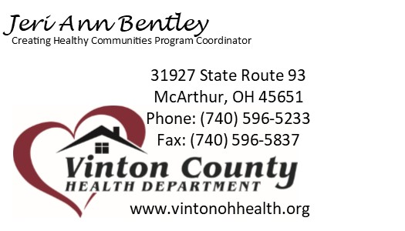
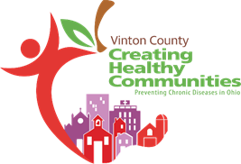
Healthy Eating Subcommittee Meeting
9/10/2020
Attendees: (in person) Lori Simonton, Bob Rannells, Bernadette Chaney, Tammy Riegel & (virtually) Troy Thacker, Miranda Smith, St. Francis Center, Anne Reichle.
Farmers’ Market Update from Bob Rannells:
- Struggling to keep consistent vendor presence
- Wilkesville has 2-3 additional vendors consistently
- New vendor coming this weekend – wood working
- Hoping to add pumpkins soon from Vinton Industries
- Have brochure ready to promote market – need to send to printer
- Hoping for Hamden extension site in near future – corner of 93 & 160
Vinton Industries Update from Troy Thacker:
- Pumpkins are growing well.
- Hoping to have fall festival/farm stand in October
- Planning to take pumpkins to the Farmers’ Market once ready
- Clients return next week
- Working with OSU extension office on community garden project
- Putting in kitchen to feed clients (Free of charge) while on site
Healthy Vending Update:
- Materials Provided: Vending Machine Tool Kit, Sample Policy, Vending Machine approved items & guidelines
- Waiting for budget approval from ODH to purchase vending machines
- Superior Hardwoods is lines up and ready to accept machines
- Several other area businesses very interested in having machines installed
- Once budget approved, will purchase sample vending items for taste testing at Superior Hardwoods
- Have complete brochure to increase community knowledge of Healthy Vending initiative – need to send to printer.

